Augmatic Technologies – Converter Module
Configurations Manual
WIN - UART TTL TO ETHERNET

Configuration Step for WIN - UART TTL TO ETHERNET Converter
- Connect 5V DC Supply to the Module.
- Connect your UART TTL device to the TX, RX, and GND terminals of the Module.
- Connect the Network Ethernet Cable to the Ethernet port of the module.
- Default IP Address of the Module is “192.168.1.254”.
- After connecting, the module is ready for UART to TCP/UDP conversion.
- Please enter “192.168.1.254” in your web browser. Make sure your device is in the same network as the Module.
- After entering the above IP Address, you will find a webpage which has 6 pages for Configurations.
Page Number 1 (System Info)
- On the first page, you will get the Current System Information of the module.
- SW Version, Microcontroller, EEPROM Health, Ethernet Chip, Ethernet Sockets, MAC Address, and IP Address are available on this First page.
- Current hardware diagnostics and active network parameters are printed directly on the page for easy monitoring.
- On the left Selection panel, you can navigate to other page information.
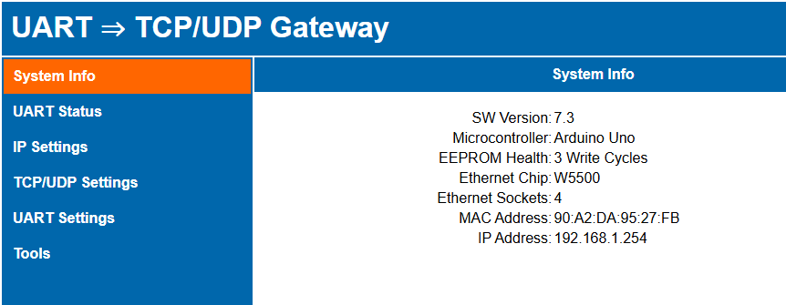
- System Info, UART Status, IP Settings, TCP/UDP Settings, UART Settings, and available Tools are placed on the Left Selection Panel.

Page Number 2 (UART Status)
- The second page is setup for live monitoring and discovery of your serial connection.
- Users can use this page to actively search for connected devices by clicking the 'UART Scan' button.
- Once the scan is initiated, the module will probe the serial bus and display any actively responding UART slave addresses (e.g., "0Ah Scanning...").
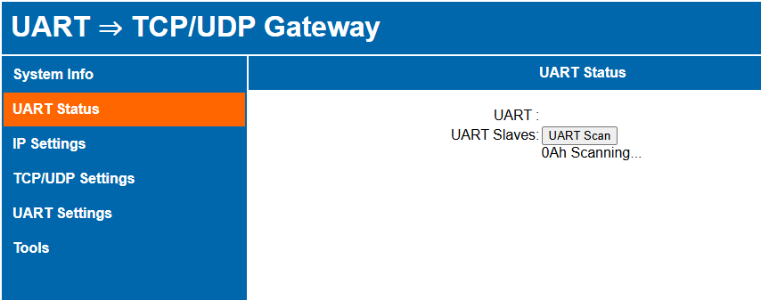
- Users should ensure the physical connections (TX, RX, and GND) are secure on the module before initiating a scan to successfully discover connected devices.

Page Number 3 (IP Settings)
- Third Page is setup for IP Settings Configuration.
- MAC Address, Static IP, Sub mask & Gateway can be set from this page.
- MAC Address randomization can be done from the third page by clicking the 'Randomize' button.
- Users must click 'Save & Apply' to confirm and save any changes made to the network parameters.
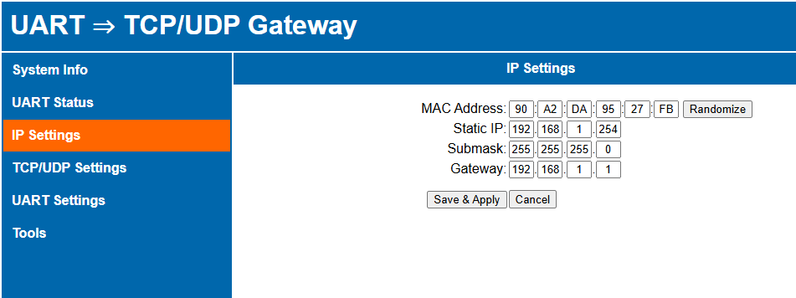
Page Number 4 (TCP/UDP Settings)
- On the fourth page, TCP/UDP configuration can be applied by the user.
- UART TCP Port, UART UDP Port, & WebUI Port can be set from this page.
- UART Mode selection can be done from the fourth page.
- UART Mode: 1. UART TCP/UDP | 2. UART over TCP/UDP
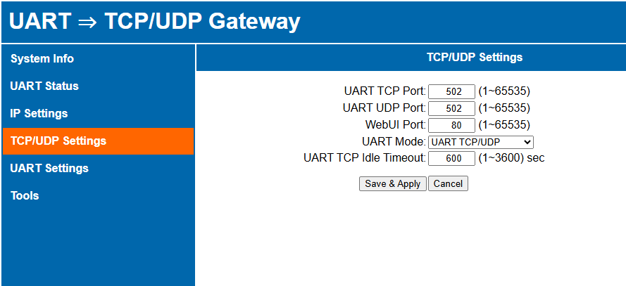
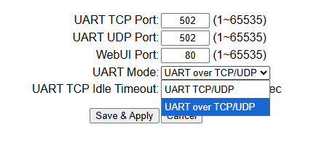
- UART TCP Idle Timeout (in seconds) can also be configured here.

Page Number 5 (UART Settings)
- Fifth page is setup for UART Settings Configuration.
- Baud Rate, Data Bits, Parity, and Stop Bits can be set from this page.
- Inter-frame Delay, Response Timeout, and Retry Attempts as well.
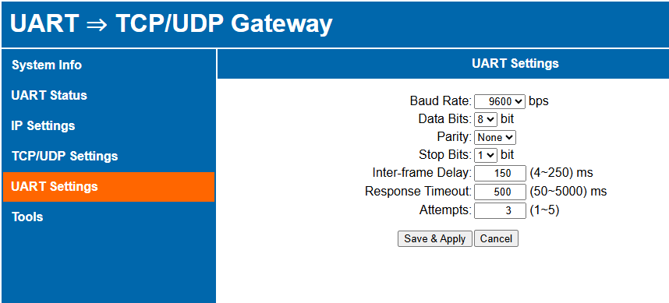
- Users must click 'Save & Apply' to confirm any changes made to the serial communication parameters. [note: it will take few seconds for values to change.]

Page Number 6 (Tools)
- The sixth page provides essential system maintenance tools for the gateway.
- It allows the user to perform a system 'Reboot' or 'Load Default Settings' to restore the factory static IP (192.168.1.254).
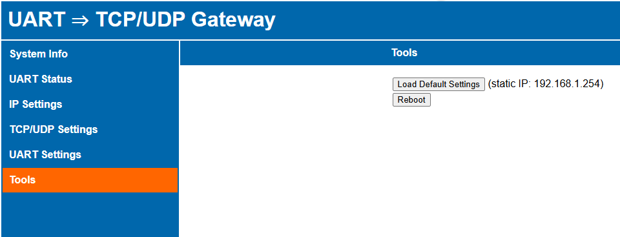
- Also, on the module you can short the header H3 (DS_RST) to reset to default settings.
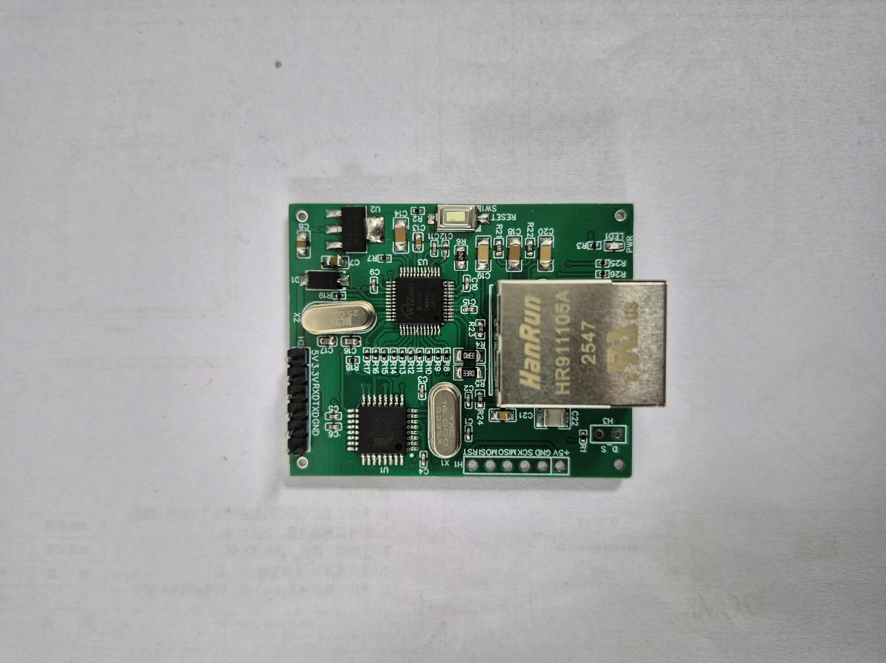
5.0 V
3.3 V
RXD
TXD
GND
GND
DS_RST
Power LED
ETHERNET PORT

Contact us: -
Augmatic Technologies Pvt. Ltd.,
Plot no 6, Shah Industrial Estate II,
Kotambi,
Vadodara – 391510.
Email – Sales@wittelb.com

